USC Rover

Subject:Mechanical advantage, motion, electricity, friction, torque  Related Subjects:Physics, Mechanical Engineering, Electronics | Grade Level(s): 2,3,4,6,8  Length of Lesson: | Type: Inquiry / Design / Project  Keywords:Series circuit, gearing, axle, chassis, alignment, horsepower (torque x rpm), suspension

Lesson Overview

Anyone who has been on a bike or in a stick shift car has felt the effects of gearing and mechanical advantage causing motion. Some energy source (your legs or a motor) causes an object to turn. That object turns another object causing the vehicle to move forward.

Lesson Focus
Each student will create a chassis, wheels, gearing system and an electrical circuit in a car that actually works! Students will then test cars for speed and endurance.
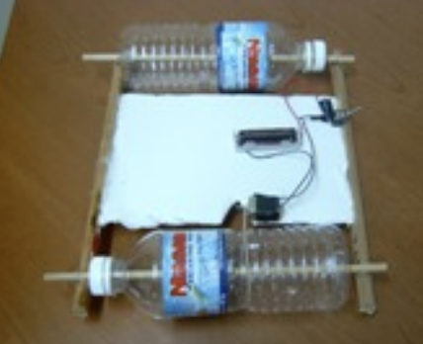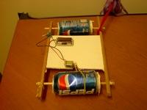

Lesson Objective(s) | - Students build suspension (wheels and axles) from cans or bottles, foam core and wood dowels.  - Students build chassis from wood base shoe and foam core.  - Students create series circuit with motor, batter holder and switch  - Students assemble USC rover.  - Students demonstrate mechanical advantage by connecting gears (motor stem to can wheel) via rubber band.  - Students determine which design leads to better performance in  - Speed  - Direction  - Incline  - “Off road” conditions  - Students will also demonstrate trade-off of beauty versus function

Lesson Timing

5 minutes | Introduce the Lesson
30 minutes | ...

Materials | - –Foam board (9 in x 5 in) – from staples  - –¼” Wood dowels (two 10 inches and two 12 inches) – from Home Depot  - –Two small water bottles (.5 liters) - collect  - –1.5V motor (from www.kelvin.com item # 850646)  - –Battery holder (single battery holder from www.kelvin.com – item # 220128)  - 1 AA battery – from any retail store  - –2 box of brass plated fasteners (1 inch) – from Staples  - –Insulated wire (from www.kelvin.com 100 feet – item # 330208)  - –Rubber bands (1 bag of standard) – from Staples  - –Hot Glue gun (provided by USC MESA)  - –Hot glue sticks – from Home Depot  - –Large paper clips – from Staples  - –Wire stripper (provided by USC MESA)  - –Exacto knives (to cut foam board) – from Staples  - –Drill (provided by USC MESA)  - –Propeller (from www.kelvin.com – item # 850891)  - ¼” wood dowel (6 inches for air powered rover)
Instructor Prep | - Step 1
Related Resources | - List related lessons/ppts etc available from USC or outside, trusted orgs

Lesson Plan

Introduction
The suspension of the rover comprises two wood dowel axles and two soda bottles. Each dowel is inserted lengthwise through a bottle. A tight suspension involves a tight fit through the foam core base for the dowel. A loose suspension allows wiggle room for the dowel (a larger hole) inside the foam core base.

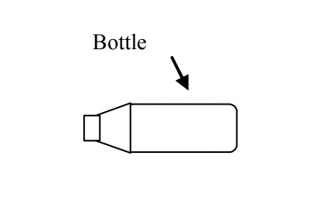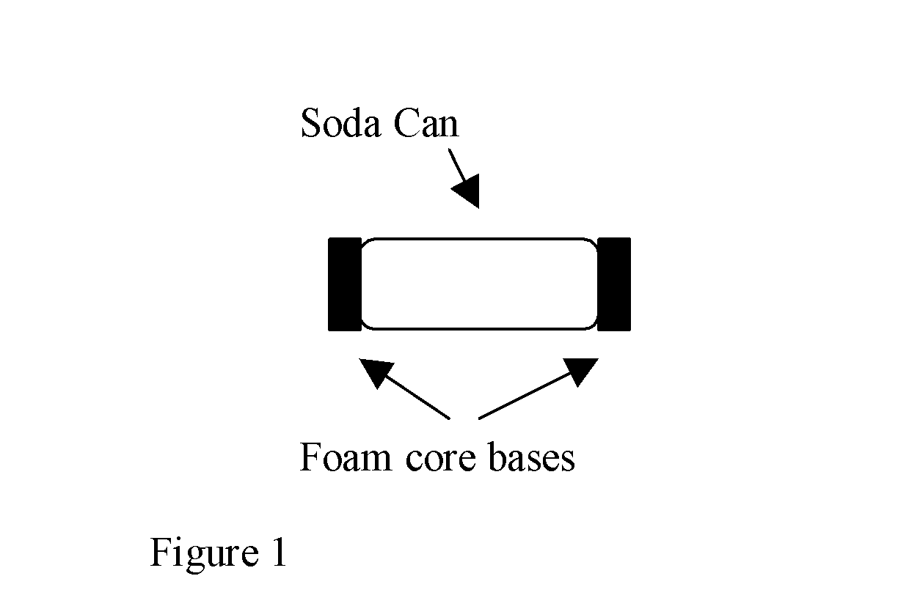

Figure 1

The chassis of the rover has to be:
1. Sufficiently thick to carry the weight of the motor, switch, and battery holder.
2. Sufficiently long to accommodate front and back wheels.
3. Sufficiently sturdy to withstand the torque and pull of the motor, belt and rear wheels.

The “H” shape model is the usual standard.

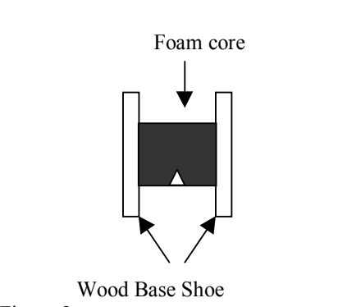
Figure 2

A series circuit is formed when an electrical source (battery) is connected to an object (motor, light...) which is connected to a switch which is connected back to the battery.
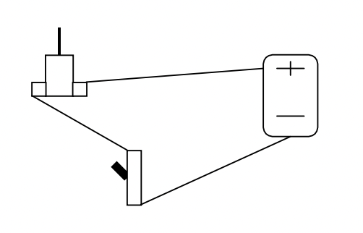

Figure 3

When the switch is off, the circuit is open and electricity can’t flow. When the switch is on, the circuit is closed and electricity can flow.

The rover must be assembled so that the wheels are placed at either end of the chassis and the motor stem is parallel to the rear wheel. A rubber band goes around the motor stem and rear wheel as a belt. This is the gearing system. The mechanical advantage is the ratio of the diameter of the bottle to the diameter of the motor stem. The greater this number, the stronger the turning force. The variables to this design are in chassis length and width, suspension, and placement of the motor.

Procedure
Instructions for bottle wheels
1. –Drill a hole in both ends of both water bottles (through cap)
2. –Cut 2 - 1/8”dowels about 3 inches longer than the bottles.

3. –Insert a dowel through both holes of water bottle (this is the wheel- axle)

4. –Repeat step for the other bottle.
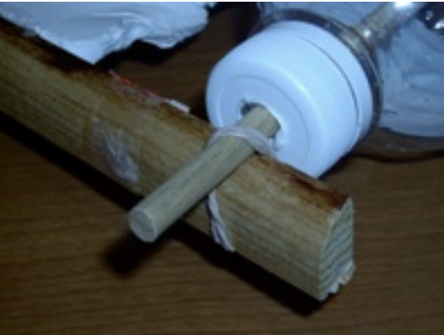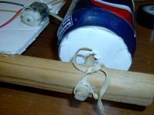

Instructions for car assembly

1. –Cut a rectangle from the foam core (the width must be longer than a bottle).
2. –Cut a “V” in one end.
3. –Cut 2 pieces of 1⁄4” wood dowel . The wood must be long enough for both bottles to spin freely when connected to the chassis.
4. Axles will be attached with rubber bands

5. –Glue the foam core to the pieces of wood dowel using the “H” shaped model (figure 2).
6. –Strip the wires of a battery holder.
7. –Cut and strip a 4” wire
8. –Twist wire to one lead of motor and tape.
9. –Twist black wire from battery holder to second lead of motor and tape.
10.–Place red wire inside fastener and put fastener in on one end of paper clip and insert through foam board
11.–Place other end of 4” wire in second fastener and insert into foam boardmso that the other end of paper clip can overlap it when it swings around
12.–Place three rubber bands around each bottle.
13.–Attach wheel-axle suspension to chassis by inserting dowel ends into holes of wood on both ends (figure 4 below).
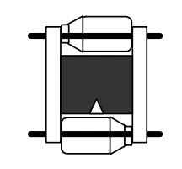

Figure 4

14.–Secure wheel-axle by wrapping rubber bands on both ends of axle (on outside of 1⁄4” wood dowel) front and back.
15.–Place tape over openings on motor and glue motor to chassis with the stem parallel to wheel axis and over the “V” (figure 5) Stem facing right makes car move one way, stem facing left makes car move the other way. Student must test before gluing to determine which way to glue motor.
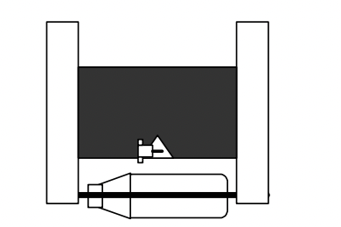
Figure 5

16.–Glue battery holder to foam core or wood.
17.–Place small piece of glue stick around stem of motor (student may have to place holder on end of stem to keep rubber band from sliding off).

Wrap-up
- Students compete for speed, direction, distance on incline, obstacles run over to determine the effect of suspension, chassis design, motor placement, wheel placement and alignment have on motion, friction, and horsepower.

Lesson Background for Teachers

Safety Procedures
• Caution should be exercised with cutting utensils (scissors, X-acto
blade).
• Students should be careful with hot surfaces (glue gun, soldering iron).
• Proper safety procedures and equipment should be used for drill, drill
press and belt sander.

